LOK JAGRUTI KENDRA UNIVERSITY
M.Sc. Cybersecurity Semester III
Class Test
Subject Code:340110317 Date: 28/10/2026
Subject Name: Digital Forensics and Incident Response
Duration: 01:00 Hour Total Marks: 10

NOTE: All the Practical’s are compulsory
- Mention Set number & Enrollment number in the answer sheet (If not written or wrong set number is written then answer sheet will not be evaluated and marked zero.)
- Also, only if the answers are correct then and then marks will be given
- Make sure no other documents apart from the necessary documents (which require during exam) for the exam should be open (If open then liable for the UFM)
- For the Viva, if student can’t answer the question, then 0 marks will be given by the invigilator/ viva taker.
- During exam, if student finds doing any copy paste from any document or taking help from the online medium then answer won’t be accepted and will get 0 marks for the whole exam (UFM)
- Students can write down the analysis according to the steps, make sure steps include technical words only (If not then marks will be given accordingly).
- Also Screen Shot should be appropriate as per the steps and important things must be highlighted in the Screenshot with the Timestamps (If not then marks will be given accordingly)
- Most Importantly, screenshots without proper visibility of timestamps will not be considered and the student can be liable to get 0 marks.
- If any students have just mentioned the Steps without appropriate Screenshots, then the question gets 0 marks.
- If the Browser history Screenshot before and after the exam is not there then marks will be deducted accordingly.
- Answer sheet will only be accepted in the google classroom submission (If students fail to submit on time due to any reason, they will get 0 marks)

ANSWER SHEET
Practical: 01
SET 2

AIM: “USB Connection Check: A lab computer may have been used to copy restricted data to a USB drive. From the instructor-provided Registry Artefact set or USBDeview output, identify the device details available (such as vendor/product, serial number, and first/last connection data if present.) Record the source artefact and explain whether the evidence alone proves that files were copied.”

Procedure

Step 1: For Recording USB Information Open USBDeview

Open USBDeview and wait it’s load connection device information.
Find USB device by viewing decription and dubble click it. You see all detailed information of that USB
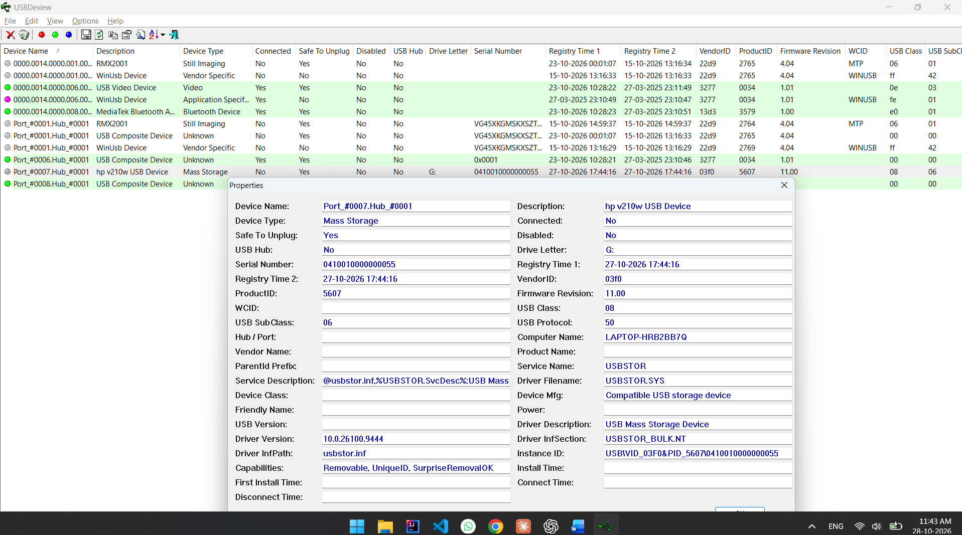
Figure 1: USB Device Inventory Using USBDeview
POC Explanation:
Here this screebshot showing all device informations. And we see second last is USB drive.
Here in new windows we see USB device name “hp v210w USB Device”.

Details we see:
Device Name: Port_#0007.Hub_#0001
Device Description: hp v210w USB Device

Serial Number: 0410010000000055
Registry Time: 27-10-2026 17:44:16
Vendor ID: 03f0
Product ID: 5607
Instance ID: USB\VID_03F0&PID_5607\0410010000000055
Driver Version: 10.0.26100.9444
First Install Time: not aveliable

Step 2: View USBSTOR Artefacts

Open Registry Explorer and then open SYSTEM registry hive
After open SYSTEM hive that showing on left panel expend it.
And open ROOT\ControlSet001\Enum\USBSTOR and then click on USBSTOR.
USBSTOR is store all information of USB devices
Now click on USBSTOR and on right panel showing its details

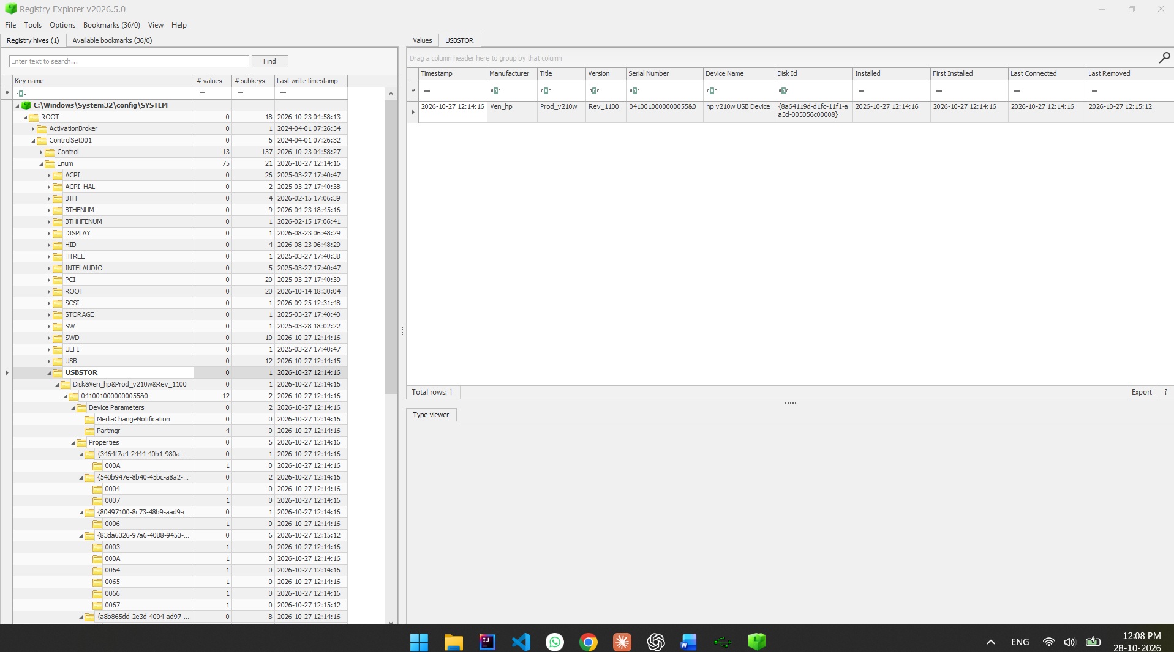
Figure 2: USBSTOR Artefacts in Registry Explorer

POC Explanation:
Here screenshot showing USBTOP artefact, left panel showing path and right panel showing UBS details information
Timestamp: 2026-10-27 12:14:16
Menufacturer: Ven_hp
Title: Prod_v210w
Version: Rev_1100
Serial Number: 0410010000000055&0
Device Name: hp v210w USB Device
First Installed: 2026-10-27 12:14:16
Last Connected: 2026-10-27 12:14:16
Last Removed: 2026-10-27 12:15:12

Step 3: Compare the Results from Both Sources

Comparison shows that both tools identify the HP v210w USB storage device.
Serial number matches across the two sources. USBDeview and displays Vendor ID 03F0, Product ID 5607, and drive letter G:
By this we not proves that same files copy from computer or not

OBSERVATION
USBDeview and Registry Explorer were used to examine USB device history on the authorized Windows system. Both sources contained information identifying an HP v210w USB storage device, including a matching serial number. USBDeview provided additional details such as Vendor ID, Product ID, drive letter, connection status, and registry timestamps.

CONCLUSION
The practical was completed successfully. USB device history was examined using USBDeview and Registry Explorer, and the findings from both sources were compared and documented. The exercise demonstrated how Windows USB artefacts can support device identification and forensic investigation. It also showed that USB presence alone does not prove file transfer or identify the person who used the device.

*** END OF ANSWERSHEET ***

